We Become One When You Receive My Body & Blood Each Day
September 10, 2017

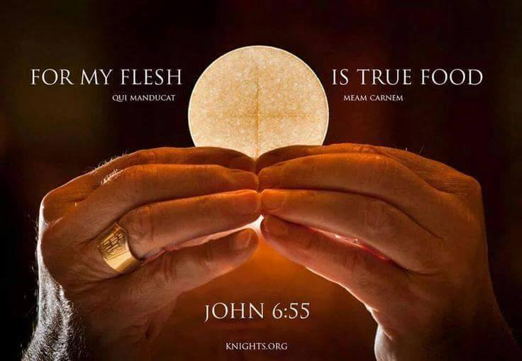
May our hearts be smitten with the Love of Our Jesus, who shed His own blood to pay for our sins and then left us access to His lifeblood through communion. Amen

Jesus began, "I want to talk about communion and the necessity of staying close to Me through communion. Words are powerful, My people. Words coupled with faith are powerful. Even saying to that mountain 'be removed into the sea', even saying that, in faith, accomplishes the end. And to say, 'This is My Body, which will be given up for you'…to say that in obedience to My command, with conviction, is powerful.

“'Do this in remembrance of Me.'

"It is written as I said it, 'If you do not eat My Body and drink My Blood, you have no life in you.' The life is in the blood, so when you say, 'This is My Blood' in total faith, shall I not visit you with My Life’s blood and strengthen you? The Life is in My Blood, not the wine. And when you proclaim in faith that this IS My Blood, I visit you with the graces you believe you are receiving from Me, because you obeyed.

"These are the days of the apostate church. Even those who have received the mark of ordination, the indelible mark passed on by the breath of the apostles to current times—even if that is done properly, there is no guaranteeing that the soul receiving this gift will say with sincere faith and intention that I am transforming the wine into My blood when they say the words.

"So, how do I deal with this apostasy and unbelief?? I visit you with the graces you need. You intended to drink My Blood and eat My Body and I honor your intention. In this way, My covenant with you, My Church, is not made void by the worldly, unbelieving ministers of the altar.

"During the wedding party at Cana, the servants never thought for a moment that the water would become wine; but as a demonstration of My faithfulness, I transformed it to wine. Do you understand? This was a foreshadowing of the Eucharist, the Body and Blood transformed at the last supper.

"I have called you all to My table to be given new life—and not just new life, but My life, God’s life, so that you may live in Me and I in you. So that you can accomplish all I have willed for you to do. So that you can love others as I love them. So that you can walk in power over the dark forces of this world and put them to flight.

"I have given you this gift because you can hardly operate without it. The opposition sent against you every day is fierce and consuming. But with My Blood, you will stand and even rebuke, break and bind those powers, because My life lives in you. No matter that you are not ordained, that is, that you've been breathed on as I first breathed on Peter. No matter—you ARE My church; I abide in you and you abide in Me. And each day, when you receive Me in communion, you are renewing the new covenant with your faith. 'This is My Body, this is My Blood. The Body and Blood of the New Covenant; it will be shed for you and for all for the forgiveness of sins.'

"So I am asking you, My chosen ones, dwellers of My Heart, receive Me each day in complete reverence and thanksgiving—even remembering the Blood I poured upon the Mercy seat positioned by the prophet Jeremiah, exactly beneath the Altar of Sacrifice, that is, the Cross on which I was crucified. And note that I died of a broken heart; the water and blood mingled and the volume was sufficient to carry it downwards 20 feet and stain the walls. None of the other victims shed their blood in this way. This was done by My Father to pay the debt of your sins forever.

"Therefore, when you remember Me in this sacrament, (that is a gift and tool given to the Church to prepare her for Heaven) remember the horrendous circumstances of My death and how My Father wasted not one drop, but saw to it that it was sprinkled on the mercy seat, that all might be fulfilled in Me when I said:

“'It is finished.'

"These are profoundly holy precepts and understandings, and I wish for you to take your time with them and meditate upon the full meaning of My death for you and all mankind."

So, at this point, I just want to give you a head's up on how to find a Communion Service - and all the teachings that the Lord has given me on that subject. First of all, go to our Heartdwellers website, and go to the search page. Type in Communion Service and click on 'search'. It'll bring up the words that are used: communion and service, over and over again, and that's not really what you want. You'll notice, right above that on the page, just above the search terms it says, 'search for these terms on Google.' If you click on that, then it will order everything according to the theme. So, you'll get the Communion Service video up that way.

God bless you all, Dear Heartdwellers. Let's take these words really, really to heart. And with great severance, celebrate what the Lord did for us each day, so we can walk in His power and His anointing.

